**Basic Git Fundamentals**

-Isha Gorashiya

-91900133033

**What is Git?**

Git is a DevOps tool that helps us to store the source code and helps managing it. It is open-source version control system.

It records the changes into special database called repository. We can look upon the project history and changes made in it. If there exists any need to revert the project back, we can do it without any trouble.

**What is Version Control System?**

With the help of it, we can Track the history and Collaborate in a project anytime from anywhere.

It falls into 2 categories:

1. **Centralized:**

The developers needed to collaborate with other developers on other systems. The localized version control system failed in this case. To deal with this problem, Centralized Version Control Systems were developed.

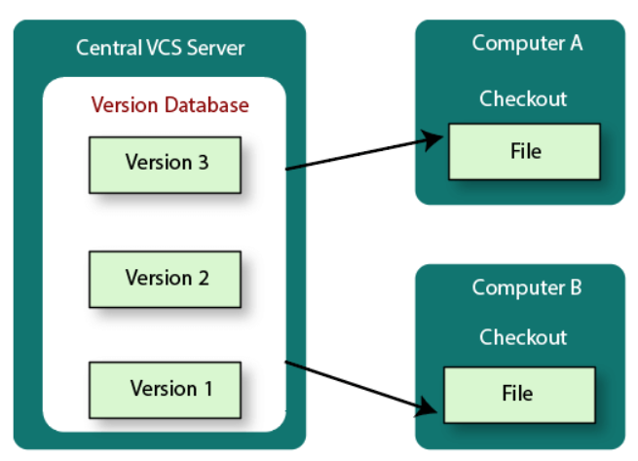

1. **Distributed:**

In a Distributed Version Control System (such as Git, Mercurial, Bazaar or Darcs), the user has a local copy of a repository. So, the clients don't just check out the latest snapshot of the files even they can fully mirror the repository. The local repository contains all the files and metadata present in the main repository.

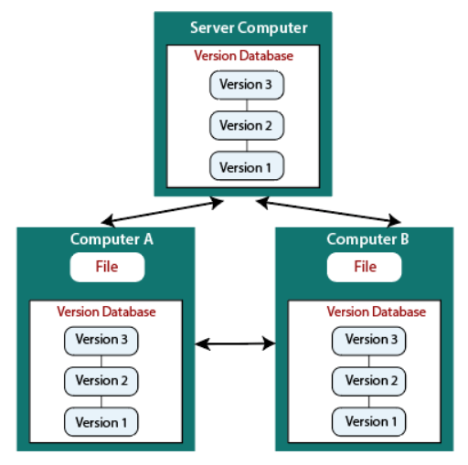

**Difference:**

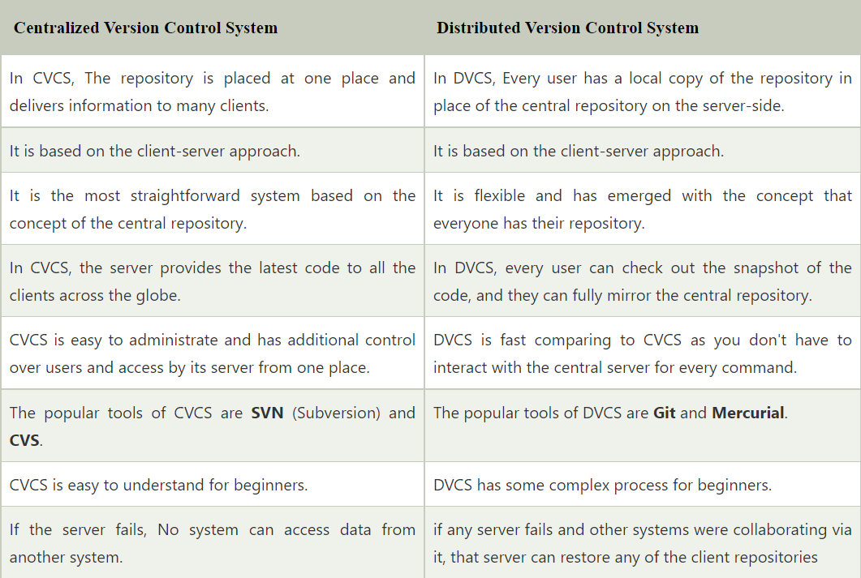

Reference: <https://www.javatpoint.com/git-version-control-system>

**Push:**

The git push command is used to upload local repository content to a remote repository. Pushing is how you transfer commits from your local repository to a remote repo.

**Pull:**

The git pull command is used to fetch and download content from a remote repository and immediately update the local repository to match that content.

**Branching:**

A branch represents an independent line of development. Branches serve as an abstraction for the edit/stage/commit process.

**Merging:**

Git merge is a command that allows you to merge branches from Git.

Merging is a common practice for developers. Whether branches are created for testing, bug fixes, or other reasons, merging commits changes to another branch. It takes the contents of a source branch and integrates it with a target branch.